AJAX = Asynchronous JavaScript And XML.
AJAX is not a programming language.
AJAX just uses a combination of:
- A browser built-in XMLHttpRequest object (to request data from a web server)
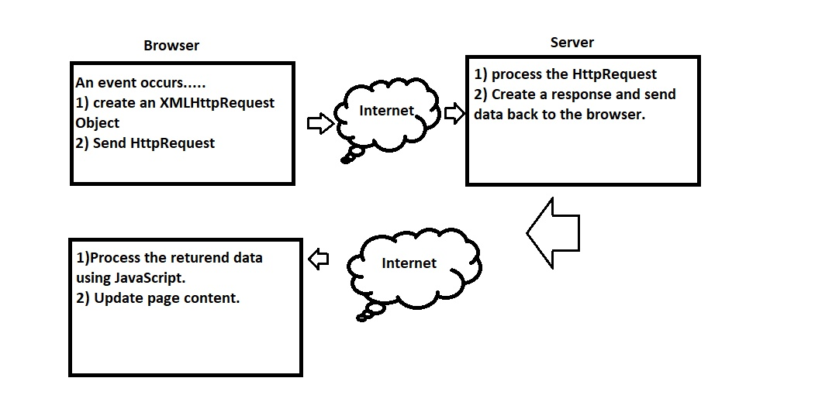
The XMLHttpRequest object is used to exchange data with a server.
To send a request to a server, we use the open() and send() methods of a XMLHttpRequest object:
Open(method,url,async)
Server response:
4 stage:-> use onreadystatechange (onreadystatechange stores the function that will process the response from the server.)property:
- Connection
- Server process
- Response for process.
- Ready to send the response.
Status:
Check ok or error -> 200 is ok, 404 error.

